MODULE 6 UNIT 2

Activity submission

Learning outcomes:
LO1: Outline the different types of process modelling techniques.
LO2: Identify the different levels of abstraction in process modelling.
LO3: Describe BPMN and modelling rules.
LO4: Apply BPMN conventions to produce business process models.
LO5: Investigate how to create a process model using BPMN.
LO6: Analyse how to develop a system architecture model.

1. Instructions and guidelines (Read carefully)

Instructions
1. Rename your file name and save the file as: First name Surname Activity Submission 6 – e.g. Lilly Smith Activity Submission 6. NB: Please ensure that you use the name that appears in your student profile on the Online Campus.
2. Write all your answers in this document. Do not adjust answer table dimensions. If your answer does not fit into the table, then your answer is too long. Diagrams that are illegible, distorted, too small to view, or not entirely contained within the allocated answer space risk not being assessed.
3. Submit your assignment in Microsoft Word only.
4. Do not delete the plagiarism declaration or the assignment instructions and guidelines. They must remain on your assignment when you submit.
PLEASE NOTE: Plagiarism cases will be penalised according to the Head Tutor’s and GetSmarter's discretion.
IMPORTANT NOTICE: Please ensure that you have checked your course calendar for the due date for this assignment. This calendar is available on the Online Campus.

Guidelines
1. This activity submission is based on the activity submission scenario for Module 6. You can download the activity submission scenario document from the Online Campus.
2. There are initially seven pages and two questions in this assignment.
3. Make sure that you have carefully read and fully understood the questions before answering them. Answer the questions fully but concisely and as directly as possible. Follow all specific instructions for individual questions (e. g. “list”, “in point form”).
4. Answer all questions in your own words. Do not copy any text from the notes, readings or other sources. The assignment must be your own work only.
Plagiarism declaration:
1. I know that plagiarism is wrong. Plagiarism is to use another’s work and pretend that it is one’s own.
2. This assignment is my own work.
3. I have not allowed, and will not allow, anyone to copy my work with the intention of passing it off as his or her own work.
4. I acknowledge that copying someone else’s assignment (or part of it) is wrong, and declare that my assignments are my own work.

2. Mark allocation
Each part of the question receives a mark allocation. However, you will only receive a final percentage mark and will not be given individual marks for each question. The mark allocation is there to show you the weighting and length of each question. Please note that line limits for each question do not indicate mark allocation. You are required to stick to the line limits.
Answer all questions clearly and succinctly.
Question 1 (Unit 1 and 2): BPMN and modelling a business process 100
Question 2 (Unit 3): Create a system architecture model (SAM) 50
TOTAL: 150 marks

3. Assignment questions

Question 1: Develop a process model using BPMN
(Please note that this question relates to the content in Units 1 and 2.)
In this module, you have been learning about business process models, the different types, their different levels of abstraction, and how to create them using BPMN 2.0 notation.
Instruction: Create a process model of the sales overview process for Kabeljou based on the workshop you held with Marius, as described in the scenario document for Module 6.
Further instructions:
- Be guided by the scenario content and requirements for the model as stated in the scenario in points 1 through 26.
- As with any SDLC and the requirements elicitation process, it is likely that previously-elicited requirements (i.e. information in scenario documents provided in previous modules) conflict with specifications provided in this scenario document for Module 6. Note that the requirements described in Module 6’s scenario document supersede all previous requirements for this business process.
- Pay particular attention to instruction #2 on page 2 of this activity submission about answer formats and answer limits. In particular, if your text is not legible on an A4 page, it cannot be assessed. Specifically, text in your diagram must be no smaller than the body text in this assignment file when it is set to Arial size 9, like this. For a reminder of other diagram requirements, review the diagram instructions in Module 4.
- You may use any tool of your choice, including a hand-drawn diagram, as long as you adhere to BPMN 2.0 modelling guidelines.
- Insert your diagram into the table provided on the next page.
How to create your diagram and insert it into this document:
Draw.io is recommended and technical support is offered if you use this software. If you draw your diagram by hand and photograph it (instead of scanning it) ensure the lighting is good so that colours contrast well and text is legible.
Once you have created your diagram, either save it as a PNG or JPEG file and insert it into the appropriate answer box, or take a screenshot and paste it into the answer box. To insert the file, put the cursor in the answer box, then insert the file containing your diagram.

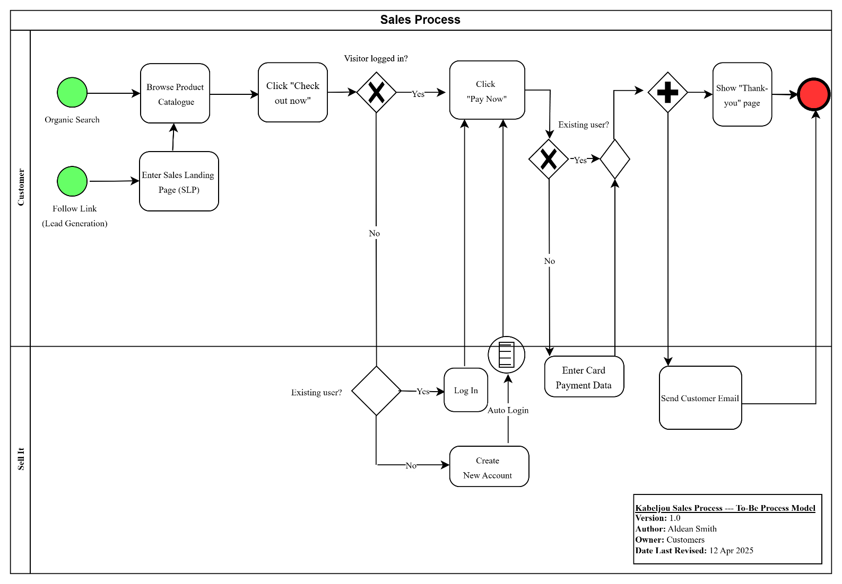

Mostly workable, with some room for improvement. Please see sample answers and general feedback posted to the forum for added guidance.

Question 2
(Please note that this question relates to the content in Unit 3.)

Instructions:
Create a system architecture model for Kabeljou based on the scenario document for this module and insert it into the table on the next page. Hint: focus on the system’s software components and not, for example, hardware configuration or networking.
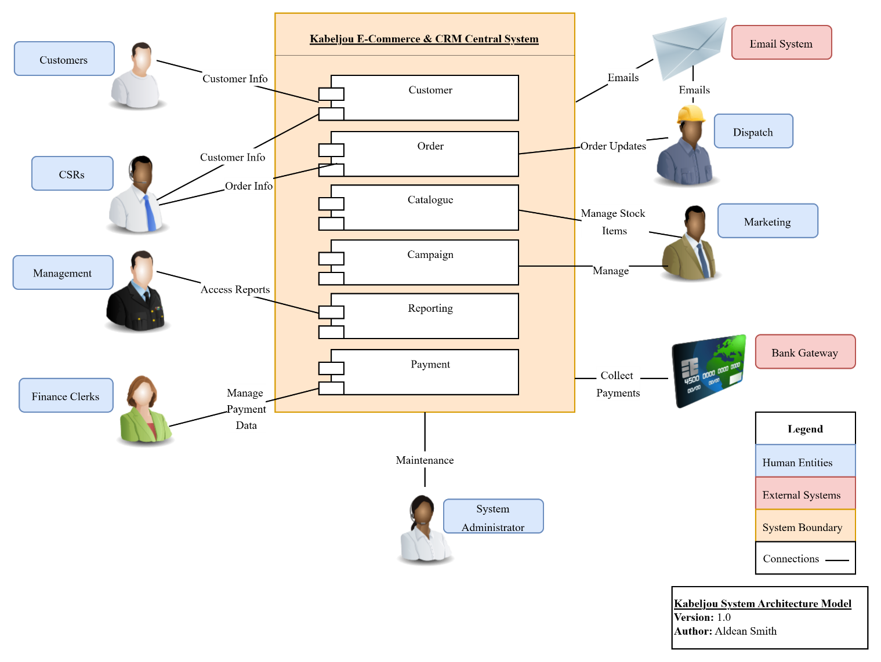

Mostly workable, with some room for improvement. Please see sample answers and general feedback posted to the forum for added guidance.
Total score: 70%

